Compare more than 2 means by analyzing the variance with ANOVA

ANOVA: ANALYSIS OF VARIANCE IN MEANS

Very important for D.O.E.

1. ANOVA SINGLE FACTOR

Se mide la contaminacion de un rio analizando la cantidad de oxigeno que contiene en disolucion el agua. Se toman muestras de 4 lugares (a 10, 25, 50, 100 kilometros del nacimiento). Existe diferencias significativas en el nivel medio de contaminación a distintas alturas del cauce? 1 factor: distancia

Tools – Data Analysis

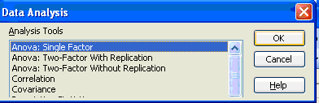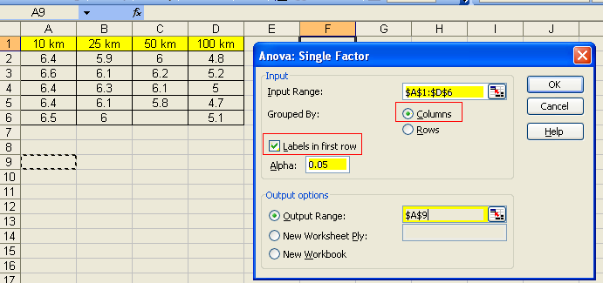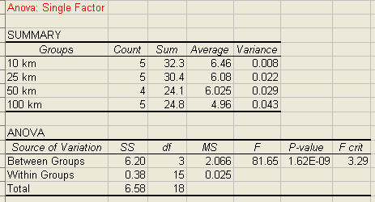

Between groups: Units to compare, in this case: Distance, kilometers to compare

Within groups: Error

F calculated = 81.65

F critic = 3.287 = 3.29 = F 0.05, 3, 15 = FINV (0.05, 3, 15)

INTERPRETATION:

F calculated > F critic 81.65 > 3.29

It is statistical significant

We reject Ho and we conclude that there is a 95% confidence that means are not equal

Observing, the Ho was rejected because of the mean in 100 kms 4.96 its mean is very different from the other means around 6.1

1. ANOVA 2 FACTORS WITHOUT REPLICATION

2 factors: Instructors measuring and Materials

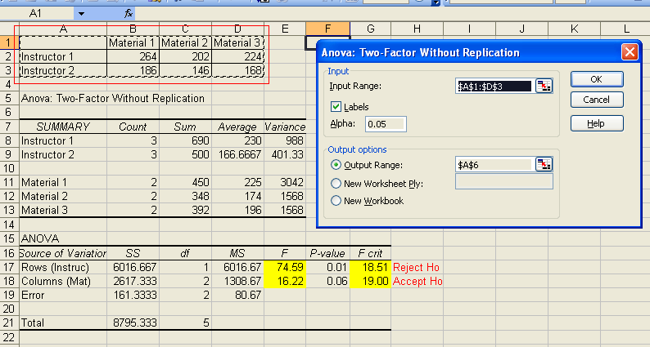

INTERPRETATION:

We reject Ho if F calculated > F critic

a) We reject with 95% that there is consistency between instructors (this mean each instructor measures very different, we need to standardize their procedure)

b) We accept with 95% that there is consistency between materials (this mean each material is similar in their measurement

Conclusion: the problem is in the instructors only

1. ANOVA 2 FACTORS WITH REPLICATION

We want to compare 2 instructors, they do 3 measures for each material, we would like to know if there is consistency in their measures and between the instructors.

* 2 Factors: Instructor and materials
* 3 replications.

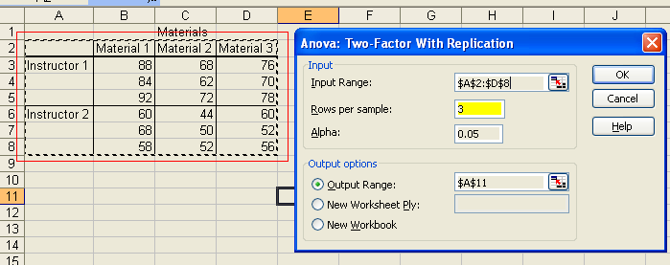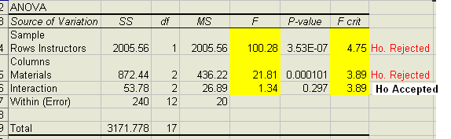

INTERPRETATION:

In 2 cases F calculated > F critic so both ARE statistical significant

a) **We reject** with 95% that there is consistency between instructors (this mean each instructor measures very different, we need to standardize their procedure)

b) **We reject** with 95% that there is consistency between materials (this mean each material is very different, this means each material has different qualities, not homogeneous)

c) **We accept** with 95% that there is consistency in interaction between instructors and materials

1. ANOVA : HOW MUCH INFLUENCED EACH FACTOR

* 2 FACTORS: Part and techs
* 2 replications

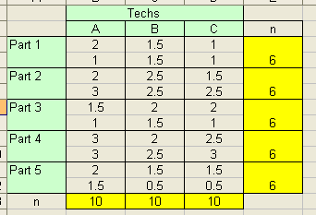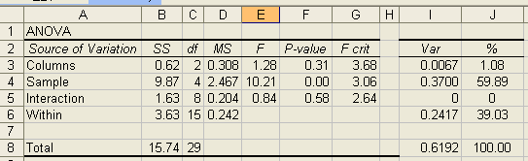

INTERPRETATION:

* Accept hypothesis, there are uniformity in Techs
* Reject hypothesis, there are not uniformity in Parts. Statistical significant
* Accept hypothesis, there are uniformity in interaction between Techs and parts

Variance, calculated: (Effect MS – Error MS ) / Variance Coefficient

In this case Error MS is 0.242

Columns (Techs) = ( 0.308 – 0.242) / 10 = 0.0067 ( For each column are 10 datas )

Rows (Material) = ( 2.467 – 0.242 ) / 6 = 0.3708 ( For each row are 6 datas )

Interactions = ( 0.204 – 0.242) / 2 = 0 (2 interactions ? replications ?)

**CONCLUSION:** The highest variance is influenced by rows (samples) Parts

1. REPEATABILITY AND REPRODUCIBILITY

Total measurement contribution = repeatability variance + technician variance

= 1.08% + 39.03% = 40.11%

If R&R is going to be reduced, it is the source of technician variation.

Process variation account for 59.89% so we need to compare total data with specifications.